

HACETTEPE UNIVERSITY

COMPUTER ENGINEERING DEPARTMENT

BBM204 SOFTWARE PRACTICUM II -2024 SPRING

**PROGRAMMING ASSIGNMENT 1**

------------------------------------------------------------------------------------------------------------------------------------------

MARCH 20, 2024

Student Name: Student Number:

İbrahim Emek b2210356032

**1 Problem Definition**

We try to sort the data, and search for an element in data using algorithms, and compare time complexity, and space complexity when the size of data increases.

**2 Solution Implementation**

First, we need to implement algorithms.

1. Insertion sort:

public static void insertionSort(int[] array)  
{  
 for (int elementAt = 1; elementAt < array.length; elementAt++)  
 {  
 int currentElement = array[elementAt];  
 int comparisonAt = elementAt - 1;  
 while (true)  
 {  
 if (comparisonAt < 0 || array[comparisonAt] <= currentElement)  
 break;  
 array[comparisonAt + 1] = array[comparisonAt];  
 comparisonAt--;  
 }  
 array[comparisonAt + 1] = currentElement;  
 }  
}

1. Merge sort:

public static int[] mergeSort(int[] array)  
{  
 int arrayLength = array.length;  
 if (arrayLength <= 1) return array;  
 int[] leftArr = Arrays.*copyOf*(array, arrayLength / 2);  
 int[] rightArr = Arrays.*copyOfRange*(array, arrayLength / 2, arrayLength);  
 leftArr = *mergeSort*(leftArr);  
 rightArr = *mergeSort*(rightArr);  
 return *merge*(leftArr, rightArr);  
}  
public static int[] merge(int[] array1, int[] array2)  
{  
 int firstAt = 0, secondAt = 0, mergedArrAt = 0;  
 int[] mergedArr = new int[array1.length + array2.length];  
  
 while (firstAt < array1.length && secondAt < array2.length)  
 {  
 if (array1[firstAt] > array2[secondAt])  
 {  
 mergedArr[mergedArrAt] = array2[secondAt];  
 secondAt++;  
 }  
 else  
 {  
 mergedArr[mergedArrAt] = array1[firstAt];  
 firstAt++;  
 }  
 mergedArrAt++;  
 }  
 while (firstAt < array1.length)  
 {  
 mergedArr[mergedArrAt] = array1[firstAt];  
 firstAt++;  
 mergedArrAt++;  
 }  
 while (secondAt < array2.length)  
 {  
 mergedArr[mergedArrAt] = array2[secondAt];  
 secondAt++;  
 mergedArrAt++;  
 }  
 return mergedArr;  
  
}

1. Counting sort

public static int[] countingSort(int[]arr, int maxEl)  
{  
 int[] countArray = new int[maxEl + 1];  
 int arrSize = arr.length;  
 int[] outputArray = new int[arrSize];  
 for (int i = 0; i < arrSize; i++)  
 {  
 int key = arr[i];  
 countArray[key]++;  
 }  
 for (int i = 1; i < maxEl + 1; i++)  
 {  
 countArray[i] += countArray[i - 1];  
 }  
 for (int i = arrSize; i > 0; i--)  
 {  
 int key = arr[i - 1];  
 countArray[key]--;  
 outputArray[countArray[key]] = arr[i - 1];  
 }  
 return outputArray;  
}

1. Linear search

public static int linearSearch(int[] arr, int value)  
{  
 for (int i = 0; i < arr.length; i++)  
 {  
 if (arr[i] == value)  
 return i;  
 }  
 return -1;  
}

1. Binary search

public static int binarySearch(int[] arr, int value)  
{  
 int low = 0, high = arr.length - 1;  
 while (high - low > 1)  
 {  
 int mid = (high + low) / 2;  
 if (arr[mid] < value)  
 {  
 low = mid + 1;  
 }  
 else {  
 high = mid;  
 }  
 }  
 if (arr[low] == value)  
 return low;  
 else if (arr[high] == value) {  
 return high;  
 }  
 return -1;  
  
}

Now, we should read csv file, and convert the data to array. I used a function:

public static ArrayList<Integer> getFlowDuration(int columnCount, String fileName) throws IOException {  
 BufferedReader reader = new BufferedReader(new FileReader(fileName));  
 reader.readLine();  
 String row;  
 ArrayList<Integer> allFlowDuration = new ArrayList<>();  
 int count = 0;  
 while ((row = reader.readLine()) != null && count < columnCount)  
 {  
 String[] allElements = row.split(",");  
 allFlowDuration.add(Integer.*parseInt*(allElements[6]));  
 count++;  
 }  
 return allFlowDuration;  
}

We read the file according to input column count (which will be how many data should we store), and file name to read. Then we store the data.

Now we should use algorithms, and calculate runtimes, and save them.

public static void main(String args[]) throws IOException {  
 ArrayList<Integer> allFlows = new ArrayList<>();  
  
 // X axis data  
 int[] inputAxis = {500, 1000, 2000, 4000, 8000, 16000, 32000, 64000, 128000, 250000};  
  
 double[][] yAxis = new double[3][10];  
 for (int i = 0; i < 10; i++)  
 {  
 allFlows = *getFlowDuration*(inputAxis[i], args[0]);  
 int[] flowArray = *convertToArray*(allFlows);  
 long time1 = System.*currentTimeMillis*();  
 *insertionSort*(flowArray);  
 long time2 = System.*currentTimeMillis*();  
 yAxis[0][i] = time2 - time1;  
 System.*out*.println("Insertion random " + inputAxis[i] + " element. Total time: " + (time2 - time1));  
 }  
 for (int i = 0; i < 10; i++)  
 {  
 allFlows = *getFlowDuration*(inputAxis[i], args[0]);  
 int[] flowArray = *convertToArray*(allFlows);  
 long time1 = System.*currentTimeMillis*();  
 *mergeSort*(flowArray);  
 long time2 = System.*currentTimeMillis*();  
 yAxis[1][i] = time2 - time1;  
 System.*out*.println("Merge random " + inputAxis[i] + " element. Total time: " + (time2 - time1));  
  
 }  
 for (int i = 0; i < 10; i++)  
 {  
 allFlows = *getFlowDuration*(inputAxis[i], args[0]);  
 int max = allFlows.get(0);  
 for (int flow : allFlows)  
 {  
 if (flow > max)  
 max = flow;  
 }  
 int[] flowArray = *convertToArray*(allFlows);  
  
 long time1 = System.*currentTimeMillis*();  
 *countingSort*(flowArray, max);  
 long time2 = System.*currentTimeMillis*();  
 yAxis[2][i] = time2 - time1;  
 System.*out*.println("Counting random " + inputAxis[i] + " element. Total time: " + (time2 - time1));  
  
 }  
 *showAndSaveChart*("Random Sort", inputAxis, yAxis);  
  
 double[][] yAxisSorted = new double[3][10];  
 for (int i = 0; i < 10; i++)  
 {  
 allFlows = *getFlowDuration*(inputAxis[i], args[0]);  
 int[] flowArray = *convertToArray*(allFlows);  
 *insertionSort*(flowArray);  
 long time1 = System.*currentTimeMillis*();  
 *insertionSort*(flowArray);  
 long time2 = System.*currentTimeMillis*();  
 yAxisSorted[0][i] = time2 - time1;  
 System.*out*.println("Insertion sorted " + inputAxis[i] + " element. Total time: " + (time2 - time1));  
  
 }  
 for (int i = 0; i < 10; i++)  
 {  
 allFlows = *getFlowDuration*(inputAxis[i], args[0]);  
 int[] flowArray = *convertToArray*(allFlows);  
 *mergeSort*(flowArray);  
 long time1 = System.*currentTimeMillis*();  
 *mergeSort*(flowArray);  
 long time2 = System.*currentTimeMillis*();  
 yAxisSorted[1][i] = time2 - time1;  
 System.*out*.println("Merge sorted " + inputAxis[i] + " element. Total time: " + (time2 - time1));  
 }  
 for (int i = 0; i < 10; i++)  
 {  
 allFlows = *getFlowDuration*(inputAxis[i], args[0]);  
 int max = allFlows.get(0);  
 for (int flow : allFlows)  
 {  
 if (flow > max)  
 max = flow;  
 }  
 int[] flowArray = *convertToArray*(allFlows);  
 *countingSort*(flowArray, max);  
 long time1 = System.*currentTimeMillis*();  
 *countingSort*(flowArray, max);  
 long time2 = System.*currentTimeMillis*();  
 yAxisSorted[2][i] = time2 - time1;  
 System.*out*.println("Counting sorted " + inputAxis[i] + " element. Total time: " + (time2 - time1));  
  
 }  
 *showAndSaveChart*("Sorted Sort", inputAxis, yAxisSorted);  
  
  
 double[][] yAxisReversed = new double[3][10];  
 for (int i = 0; i < 10; i++)  
 {  
 allFlows = *getFlowDuration*(inputAxis[i], args[0]);  
 int[] flowArray = *convertToArray*(allFlows);  
 *insertionSort*(flowArray);  
 int[] newArray = *reverseArray*(flowArray);  
 long time1 = System.*currentTimeMillis*();  
 *insertionSort*(newArray);  
 long time2 = System.*currentTimeMillis*();  
 yAxisReversed[0][i] = time2 - time1;  
 System.*out*.println("Insertion reversed " + inputAxis[i] + " element. Total time: " + (time2 - time1));  
  
 }  
 for (int i = 0; i < 10; i++)  
 {  
 allFlows = *getFlowDuration*(inputAxis[i], args[0]);  
 int[] flowArray = *convertToArray*(allFlows);  
 *mergeSort*(flowArray);  
 int[] newArray = *reverseArray*(flowArray);  
 long time1 = System.*currentTimeMillis*();  
 *mergeSort*(newArray);  
 long time2 = System.*currentTimeMillis*();  
 yAxisReversed[1][i] = time2 - time1;  
 System.*out*.println("Merge reversed " + inputAxis[i] + " element. Total time: " + (time2 - time1));  
  
 }  
 for (int i = 0; i < 10; i++)  
 {  
 allFlows = *getFlowDuration*(inputAxis[i], args[0]);  
 int max = allFlows.get(0);  
 for (int flow : allFlows)  
 {  
 if (flow > max)  
 max = flow;  
 }  
 int[] flowArray = *convertToArray*(allFlows);  
 *countingSort*(flowArray, max);  
 int[] newArray = *reverseArray*(flowArray);  
 long time1 = System.*currentTimeMillis*();  
 *countingSort*(newArray, max);  
 long time2 = System.*currentTimeMillis*();  
 yAxisReversed[2][i] = time2 - time1;  
 System.*out*.println("Counting reversed " + inputAxis[i] + " element. Total time: " + (time2 - time1));  
  
 }  
 *showAndSaveChart*("Reversed Sort", inputAxis, yAxisReversed);  
  
 double[][] yAxisSearch = new double[3][10];  
 for (int i = 0; i < 10; i++)  
 {  
 allFlows = *getFlowDuration*(inputAxis[i], args[0]);  
 Random random = new Random();  
 int randomNumber = random.nextInt(inputAxis[i]);  
 System.*out*.println(randomNumber);  
 int[] flowArray = *convertToArray*(allFlows);  
 long time1 = System.*nanoTime*();  
 *linearSearch*(flowArray, flowArray[randomNumber]);  
 long time2 = System.*nanoTime*();  
 yAxisSearch[0][i] = time2 - time1;  
 System.*out*.println("Linear random " + inputAxis[i] + " element. Total time: " + (time2 - time1));  
 }  
 for (int i = 0; i < 10; i++)  
 {  
 allFlows = *getFlowDuration*(inputAxis[i], args[0]);  
  
 Random random = new Random();  
 int randomNumber = random.nextInt(inputAxis[i]);  
 System.*out*.println(randomNumber);  
  
 int[] flowArray = *convertToArray*(allFlows);  
 *insertionSort*(flowArray);  
 long time1 = System.*nanoTime*();  
 *linearSearch*(flowArray, flowArray[randomNumber]);  
 long time2 = System.*nanoTime*();  
 yAxisSearch[1][i] = time2 - time1;  
 System.*out*.println("Linear sorted " + inputAxis[i] + " element. Total time: " + (time2 - time1));  
 }  
 for (int i = 0; i < 10; i++)  
 {  
 allFlows = *getFlowDuration*(inputAxis[i], args[0]);  
  
 Random random = new Random();  
 int randomNumber = random.nextInt(inputAxis[i]);  
 System.*out*.println(randomNumber);  
 int[] flowArray = *convertToArray*(allFlows);  
 *insertionSort*(flowArray);  
 long time1 = System.*nanoTime*();  
 *binarySearch*(flowArray, flowArray[randomNumber]);  
 long time2 = System.*nanoTime*();  
 yAxisSearch[2][i] = time2 - time1;  
 System.*out*.println("Binary sorted " + inputAxis[i] + " element. Total time: " + (time2 - time1));  
 }  
 *showAndSaveChartSearch*("Search Algorithms", inputAxis, yAxisSearch);  
  
  
}

Between time1 and time2 we use algorithms. Then we subtract time1 from time2, and we reach runtimes.

For per 3 algorithm, we create a table using showAndSaveChart function.

These functions are the other functions:

public static int[] reverseArray(int[] arrayToReverse)  
{  
 int[] reversedArray = new int[arrayToReverse.length];  
 for (int i = 0; i < arrayToReverse.length; i++)  
 {  
 reversedArray[i] = arrayToReverse[arrayToReverse.length - i - 1];  
 }  
 return reversedArray;  
}  
public static int[] convertToArray(ArrayList<Integer> toConvert)  
{  
 int[] y = new int[toConvert.size()];  
 for (int a = 0; a < toConvert.size(); a++)  
 {  
 y[a] = toConvert.get(a);  
 }  
 return y;  
}  
  
  
  
public static void showAndSaveChart(String title, int[] xAxis, double[][] yAxis) throws IOException {  
 // Create Chart  
 XYChart chart = new XYChartBuilder().width(800).height(600).title(title)  
 .yAxisTitle("Time in Milliseconds").xAxisTitle("Input Size").build();  
  
 // Convert x axis to double[]  
 double[] doubleX = Arrays.*stream*(xAxis).asDoubleStream().toArray();  
  
 // Customize Chart  
 chart.getStyler().setLegendPosition(Styler.LegendPosition.*InsideNE*);  
 chart.getStyler().setDefaultSeriesRenderStyle(XYSeries.XYSeriesRenderStyle.*Line*);  
  
 // Add a plot for a sorting algorithm  
 chart.addSeries("insertion sort", doubleX, yAxis[0]);  
 chart.addSeries("merge sort", doubleX, yAxis[1]);  
 chart.addSeries("counting sort", doubleX, yAxis[2]);  
  
  
 // Save the chart as PNG  
 BitmapEncoder.*saveBitmap*(chart, title + ".png", BitmapEncoder.BitmapFormat.*PNG*);  
  
 // Show the chart  
 new SwingWrapper(chart).displayChart();  
}  
public static void showAndSaveChartSearch(String title, int[] xAxis, double[][] yAxis) throws IOException {  
 // Create Chart  
 XYChart chart = new XYChartBuilder().width(800).height(600).title(title)  
 .yAxisTitle("Time in Milliseconds").xAxisTitle("Input Size").build();  
  
 // Convert x axis to double[]  
 double[] doubleX = Arrays.*stream*(xAxis).asDoubleStream().toArray();  
  
 // Customize Chart  
 chart.getStyler().setLegendPosition(Styler.LegendPosition.*InsideNE*);  
 chart.getStyler().setDefaultSeriesRenderStyle(XYSeries.XYSeriesRenderStyle.*Line*);  
  
 // Add a plot for a sorting algorithm  
 chart.addSeries("Linear random ", doubleX, yAxis[0]);  
 chart.addSeries("Linear sorted ", doubleX, yAxis[1]);  
 chart.addSeries("Binary sorted ", doubleX, yAxis[2]);  
  
  
 // Save the chart as PNG  
 BitmapEncoder.*saveBitmap*(chart, title + ".png", BitmapEncoder.BitmapFormat.*PNG*);  
  
 // Show the chart  
 new SwingWrapper(chart).displayChart();  
}

A function to reverse an array, a function to convert arraylist to array, and functions to create tables.

**3 Results, Analysis, Discussion**

|  |  |  |  |  |  |  |  |  |  |  |
| --- | --- | --- | --- | --- | --- | --- | --- | --- | --- | --- |
| Algorithm | 500 | 1000 | 2000 | 4000 | 8000 | 16000 | 32000 | 64000 | 128000 | 256000 |
| Random Input Data Timing Results in ms | | | | | | | | | | |
| Insertion sort | 0 | 0 | 1 | 3 | 4 | 21 | 71 | 300 | 1190 | 4822 |
| Merge sort | 0 | 1 | 0 | 0 | 0 | 3 | 2 | 3 | 14 | 23 |
| Counting sort | 101 | 99 | 102 | 102 | 100 | 92 | 91 | 89 | 98 | 92 |
| Sorted Input Data Timing Results in ms | | | | | | | | | | |
| Insertion sort | 0 | 0 | 0 | 0 | 0 | 0 | 0 | 0 | 0 | 0 |
| Merge sort | 0 | 0 | 1 | 3 | 0 | 0 | 4 | 6 | 12 | 20 |
| Counting sort | 81 | 84 | 88 | 80 | 86 | 85 | 85 | 90 | 84 | 88 |
| Reversely Sorted Input Data Timing Results in ms | | | | | | | | | | |
| Insertion sort | 0 | 0 | 0 | 4 | 12 | 36 | 142 | 592 | 2290 | 8694 |
| Merge sort | 0 | 0 | 0 | 0 | 0 | 0 | 5 | 2 | 12 | 21 |
| Counting sort | 102 | 100 | 102 | 101 | 98 | 91 | 95 | 90 | 99 | 98 |

|  |  |  |  |
| --- | --- | --- | --- |
| **Algorithm** | **Best Case** | **Average Case** | **Worst Case** |
| Insertion Sort | O(n) | O(n2) | O(n2) |
| Merge Sort | O(n log(n)) | O(n log(n)) | O(n log(n)) |
| Counting Sort | O(n +k) | O(n +k) | O(n +k) |

First, let’s look at insertion sort. In best case (In case of sorted data) time complexity is O(n), and we see all of them happened in 0 ms, because it is fast in this data. If we look at average, and worst case, we can see the difference. In small data, it is very small number, but if we look at bigger than 32000, we can see when we increase data size 2 times, runtime increases 4 time. As a result we can say that it is O(n*n) in worst case, and average case.

If we look to merge sort, it is same for all cases, and if we look at the table, they almost same in all cases. Because the data is small to see the difference clearly, I can’t say if it’s time complexity is O(nlog(n)), but we can say it is same for all cases.

It is same case for counting sort as merge sort. We can only say it is same for all cases.

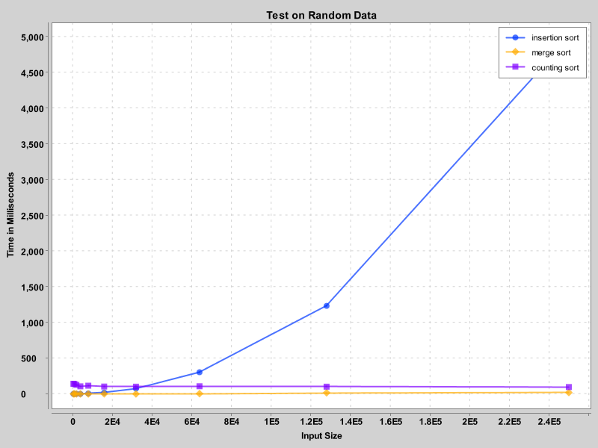

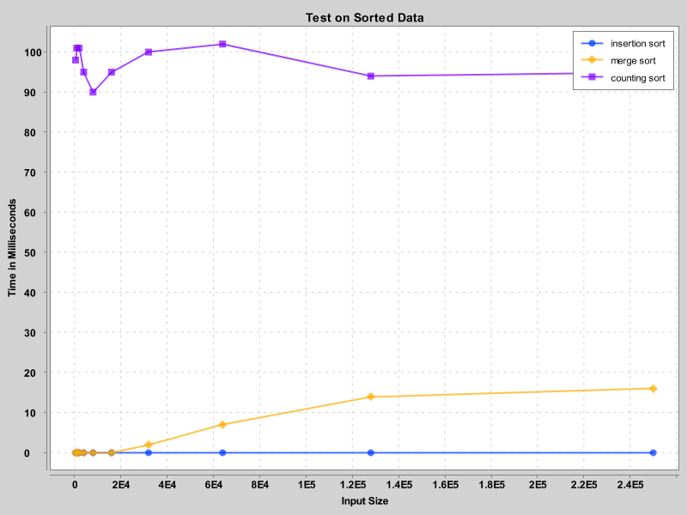

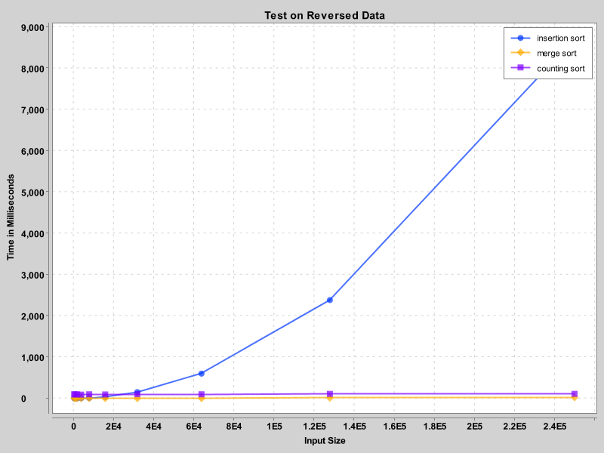

|  |  |
| --- | --- |
| **Search type** | **Time Complexity** |
| Linear Search | O(n) |
| Binary Search | O( log(n)) |

|  |  |  |  |  |  |  |  |  |  |  |
| --- | --- | --- | --- | --- | --- | --- | --- | --- | --- | --- |
| Algorithm | 500 | 1000 | 2000 | 4000 | 8000 | 16000 | 32000 | 64000 | 128000 | 256000 |
| Search Algorithm Results in nanosec | | | | | | | | | | |
| Linear Search (random data) | 370 | 240 | 570 | 3200 | 2000 | 11590 | 11100 | 42890 | 14990 | 32620 |
| Linear Search (sorted data) | 230 | 190 | 420 | 500 | 1320 | 2630 | 3930 | 8990 | 17160 | 25780 |
| Binary Search (sorted data) | 3940 | 1030 | 2190 | 1080 | 2790 | 3910 | 4200 | 5290 | 5820 | 5790 |

In linear search, runtime only depends on data size. Generally, if the size increases, the runtime increases too. It is not the case always, because we pick a random number and search it. It can be first element, and it can be last one, so we can’t say it is certain that if data increases, the runtime increases too.

In binary search, it is same as linear search. Only difference is it increases less as a result of O(log(n)) time complexity.

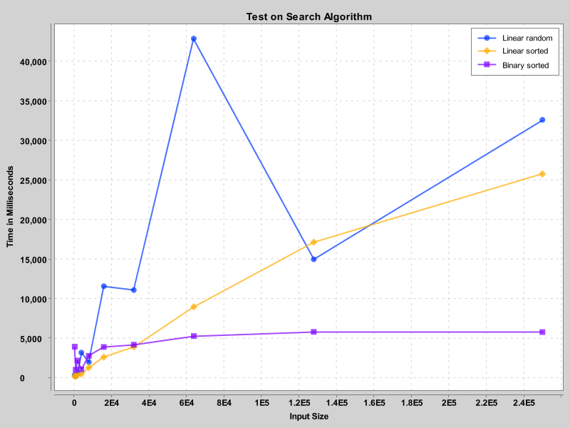

|  |  |
| --- | --- |
| **Algorithm type** | **Space Complexity** |
| Insertion Sort  Merge Sort  Counting Sort  Linear Search | O(1) O(n)  O(k)  O(1) |
| Binary Search | O( 1) |

Since there is no data stored in insertion sort, linear search, and binary search, their space complexities are O(1). In merge sort we store new data in the new array, space complexity is O(n). Because counting creates k size array, it’s space complexity is O(k).

**4 Conclusion**

In this assignment, we explored various sorting, and searching algorithms, and analyzed their performance in terms of time, and space complexity while data size increases. While we doing this, we learned their efficiencies in different scenarios.

In conclusion, we should choose an algorithm to use according to data size, available memory, and runtime with our data size. Understanding the time and space complexity will provide us efficient apps.

**References**

1. [Time Complexities of all Sorting Algorithms - GeeksforGeeks](https://www.geeksforgeeks.org/time-complexities-of-all-sorting-algorithms/)
2. [All Sorting Algorithm, Its Time Complexities & Space Complexities. | by Salveketan | Medium](https://medium.com/@salveketan6/all-sorting-algorithm-its-time-complexities-space-complexities-862d8dbf27a3)
3. [BBM204_Programming_Assignment_Report_Template.pdf (hacettepe.edu.tr)](https://web.cs.hacettepe.edu.tr/~bbm204/2024Spring/PA1/BBM204_Programming_Assignment_Report_Template.pdf)